

**YEAR: 7**

**SUBJECT: SCIENCE**

**Semester 2**

**Term 4**

**Multiple Choice Question Booklet**

**Answer Guide (Teacher Copy ONLY)**

**TEST: Resources**

**TIME: 40 minutes**

**TOTAL MARKS: 39 marks**

**DO NOT WRITE ON OR MARK THIS PAPER**

**SECTION ONE – MULTIPLE CHOICE (10 marks)**

This section has **10** questions. Answer **all** questions on the separate multiple-choice answer sheet provided.

1. Resources on Earth can be classified into 2 groups:
2. Top of Form
   1. renewable and non-renewable
   2. mineral and non-mineral
   3. metal and non-metal
   4. resourceful and non-resourceful
3. What is the world’s most commonly used source of energy?
   1. Top of Form
   2. wind power
   3. tidal power
   4. oil
   5. solar power
4. Desalination plants use which process to produce fresh water from sea water?
   1. Top of Form
   2. transpiration
   3. distillation
   4. evaporation
   5. condensation
5. 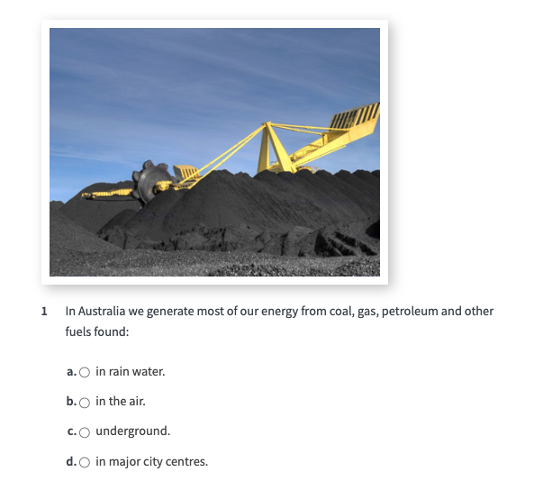

In Australia we generate most of our energy from coal, gas, petroleum and other fuels found:

Top of Form

1. in the air
2. in rain water
3. underground
4. in major city centres

Bottom of Form

1. Approximately how long ago were fossil fuels formed?
   1. Top of Form
   2. billions of years ago
   3. thousands of years ago
   4. hundreds of years ago
   5. millions of years ago
2. What are the three states of water on Earth?

Top of Form

1. groundwater, seawater, water vapour
2. gas, liquid, solid
3. ocean, river, ice
4. rain, hail, snow
5. What is the water cycle?
   1. Top of Form
6. the scientific name for rain, hail and snow
7. the natural conversion of salt water in our oceans to fresh water in our rivers
8. the process followed at desalination plants
9. the natural recycling of water on Earth
10. Soil is such an important resource to us because:
11. Top of Form
    1. soils such as sand or clay can be used in construction
    2. it provides essential nutrients for plants
    3. all of these answers are correct
    4. dead organisms break down into soil and return their nutrients to the life cycle
12. Which statement written below is correct?

Top of Form

1. not all water is a part of the water cycle
2. the amount of water on Earth is constantly changing
3. water evaporated into our atmosphere comes mainly from lakes and rivers
4. the amount of water on Earth does not change

Bottom of Form

1. Solar energy is made when __________ convert __________ into __________.

Top of Form

1. solar cells; sunlight; electricity
2. solar cells; UV rays; electricity
3. panels; UV rays, electricity
4. panels; sunlight; electricity

**END OF MULTIPLE-CHOICE SECTION**

*Please continue with short answer section in the answer booklet*



**ANSWER BOOKLET**

NAME:

FORM: DATE:

|  |  |
| --- | --- |
| **I CAN STATEMENT** | **QUESTIONS** |
| **MUST**  Draws diagrams which show forces on objects and predicts how unbalanced forces will affect an object’s motion. | 1, 2, 4, 5, 6, 7, 8, 9, 10, 11, 12, 13, 14, 15, |
| **SHOULD**  Draws diagrams which show labelled forces on objects and predicts how unbalanced forces will affect an object’s motion. | 16, 17, 18, 19 |
| **COULD**  Draws diagrams which show forces of scaled length on objects and predicts in detail how unbalanced forces will affect an object’s motion. | 20, 21 |

Multiple Choice Short Answer Total

/29

/10

**/39**

**SECTION ONE:** Multiple choice answers

Cross (X) through the correct answer.

|  |  |  |  |  |
| --- | --- | --- | --- | --- |
| **1** | X | b | c | d |
| **2** | a | b | X | d |
| **3** | a | X | c | d |
| **4** | a | b | X | d |
| **5** | a | b | c | X |
| **6** | a | X | c | d |
| **7** | a | b | c | X |
| **8** | a | b | X | d |
| **9** | a | b | c | X |
| **10** | X | b | c | d |

**SECTION TWO: Short Answer (29 marks)**

Answer questions …. To … the in the spaces provided.

1. Classify the following as either renewable or non-renewable (4 Marks)

*½ Mark Per Correct Answer*

|  |  |
| --- | --- |
| **Resource** | **Renewable/Non-Renewable** |
| Solar Energy | Renewable |
| LPG Gas | Non-Renewable |
| Coal | Non-Renewable |
| Tidal Energy | Renewable |
| Wind Energy | Renewable |
| Wood | Renewable |
| Paper | Renewable |
| Oil | Non-Renewable |

1. Our burning of fossil fuels for energy poses several different problems. State what is generally considered the *biggest*problem and the main reason for using alternatives. (2 marks)

Pollution or any other acceptable answer – **1 mark.**

Pollution is causing greenhouse gases and leading to global warming – **1 mark.**

1. True or false? The same water you drank today could have been drunk by a dinosaur millions of years ago. (1 mark)

**TRUE**

1. Use the following words to fill in the water cycle below: (4 marks)

|  |  |
| --- | --- |
| Evaporation | Precipitation |
| Condensation | Run-off |

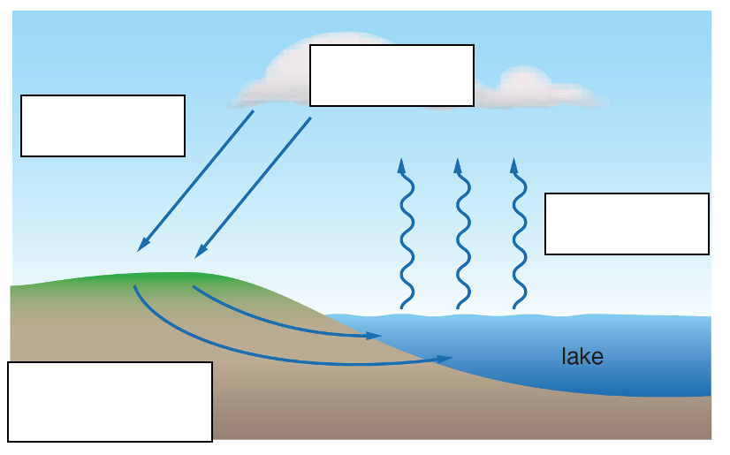

**Condensation**

**Precipitation**

**Evaporation**

**Run-off**

1. List three different sources of water on Earth

(2 marks)

* + Water in dams
  + Underground water
  + Ocean (via desalination)
  + Rivers
  + Streams (2 correct answers for 1 mark, 3 correct answers for 2 marks)

1. **Outline** how fossil fuels are formed (2 marks)

Plant and animal remains compressed under layers of soil and mud **(1 mark)**

are transformed into various types of fossil fuels over a timescale of millions of years. **(1 mark)**

1. **Describe** different **two** ways sunlight can be used as an energy source (2 marks)

Any acceptable answer e.g.

Solar cell to produce electricity (1 mark)

Solar water heating (1 mark)

1. What is the time scale for formation of non-renewable resources? What about renewable resources? (3 marks)

Non-renewable resources are formed over hundreds of thousands or millions of years. (1 mark)

They cannot be renewed in several human generations. (1 mark)

Renewable resources are always being formed. It may take a few days (solar or wind power) or a few years (trees) to fully renew the resource, but it is well within the human lifespan. (1 mark)

1. Discuss two examples within nature that Indigenous people used to locate water sources.

Provide one method of how they protected the water source once located. (3 marks)

Location of white gums (1 mark) and animal trails such as ant or dingo tracks ( 1 mark)

Placing bark over the Gnamma holes

1. **Explain** why water is considered to be a resource that is in short supply when there is so much of it on Earth and why is it so important, we recycle it. (2 marks)

There is finite amount of water on Earth **(1 mark)**

Only a very small percentage is suitable for use by humans **(1 mark)**

1. **Explain** the difference between renewable and non-renewable sources of energy, giving an example of each type. (4 marks)

A renewable energy source is one that can be used over and over again and is replaced by natural processes that occur in a timescale shorter than an average human life. **(1 mark)**

Non-renewable energy sources are limited in supply and will one day run out if they continue to be used. **(1 mark)**

Solar, hydroelectric, tidal or wind energy are examples of renewable energy sources. **(1 mark)**

Examples of non-renewable energy sources are oil, coal and nuclear energy. **(1 mark)**

**END OF ASSESSMENT** – Please check your work carefully